**2.changing default security config**

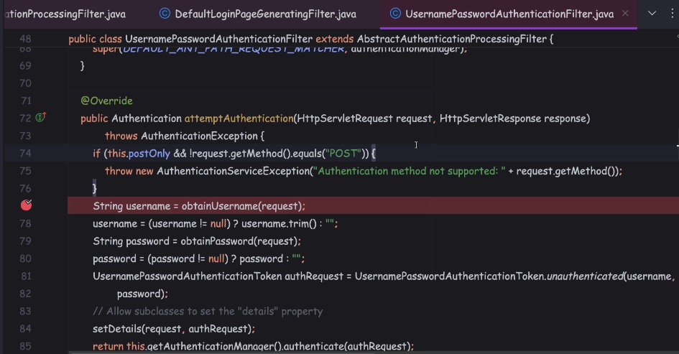

**Basic auth;**

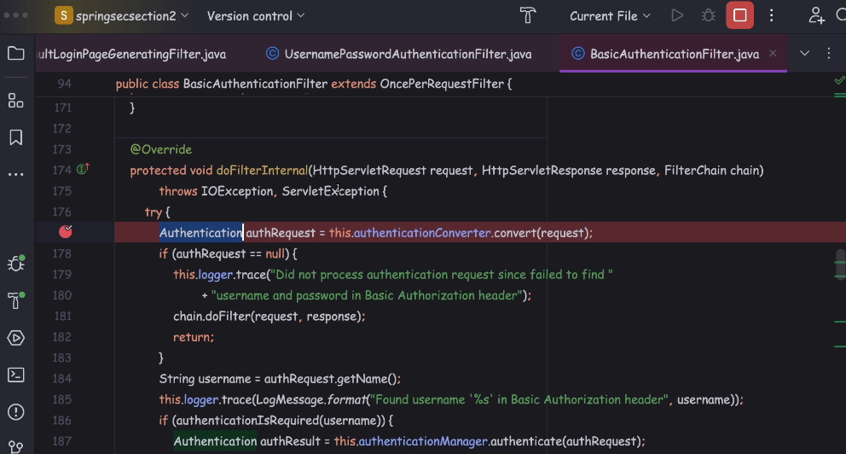

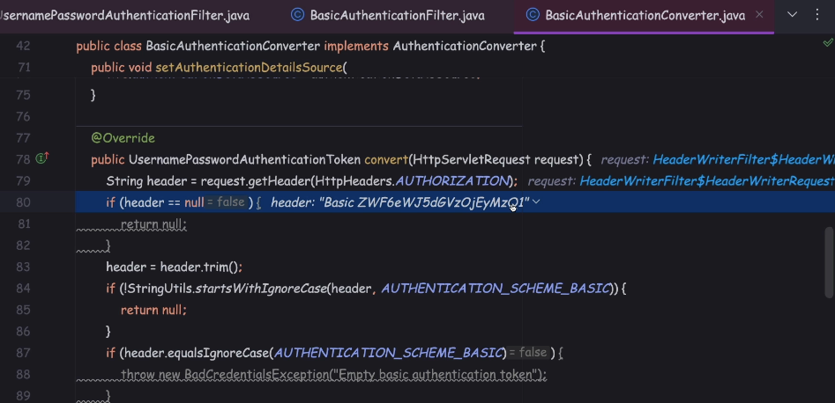

So both the username and passwords,

they're going to be separated using the delimiter colon.

So this entire content, which is username:password, they're going to be encoded

with the help of Base64 encoding.

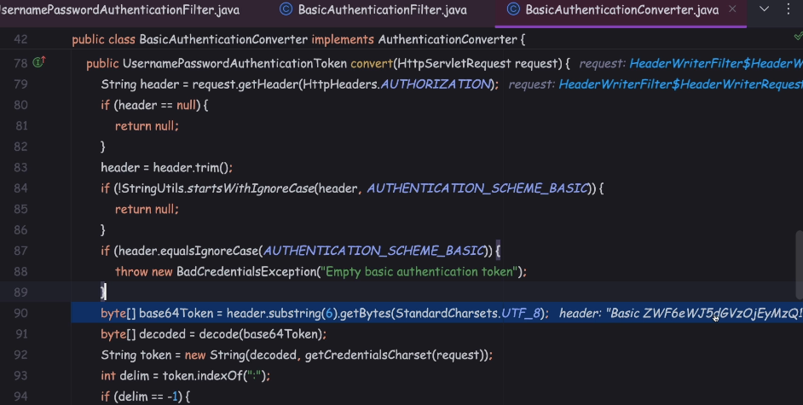

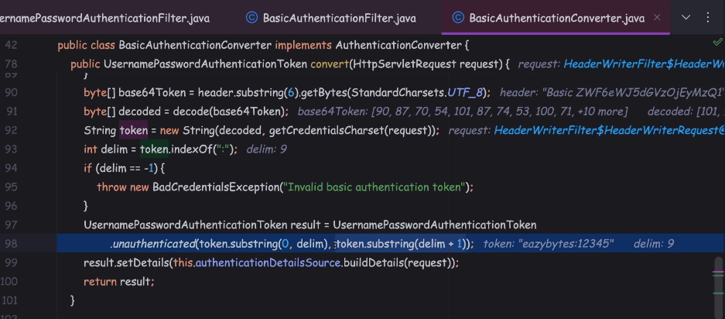

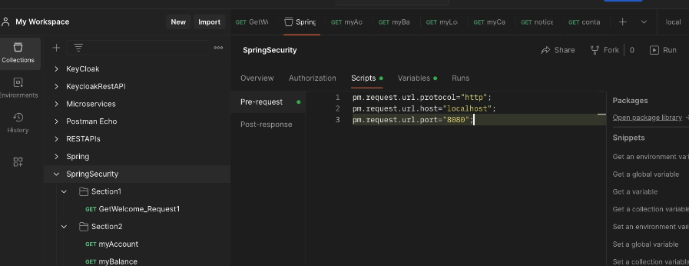

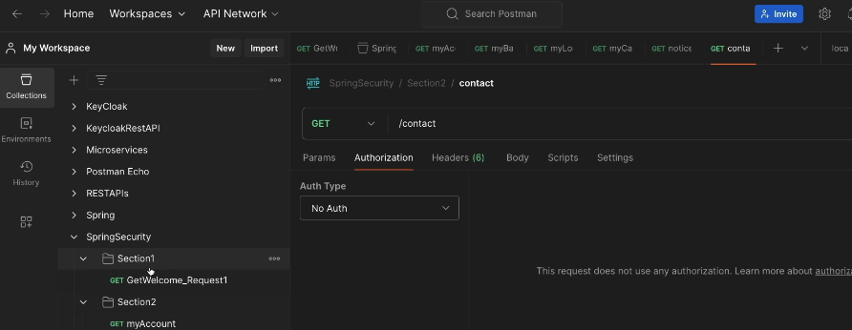

Configuring users using InMemoryUserDetailsManager

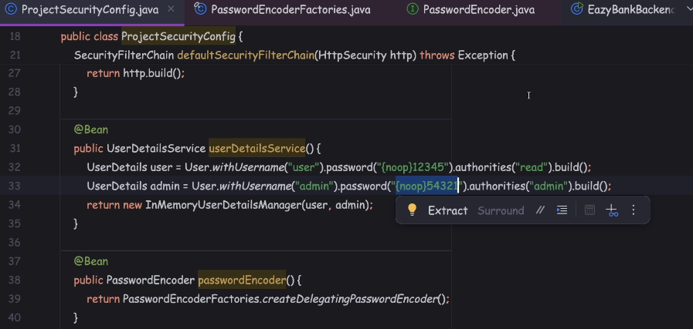

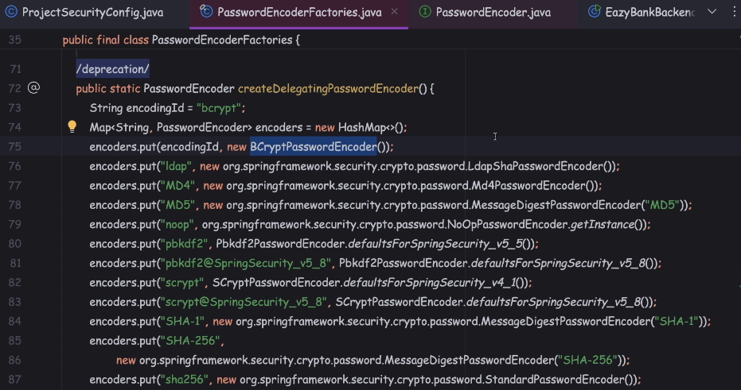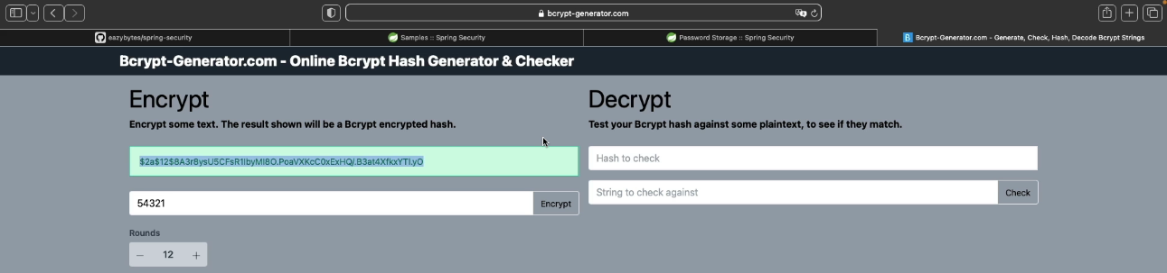

Because by default, if I don't mention the prefix, the Spring Security framework,

it is going to consider the bcrypt as the prefix.

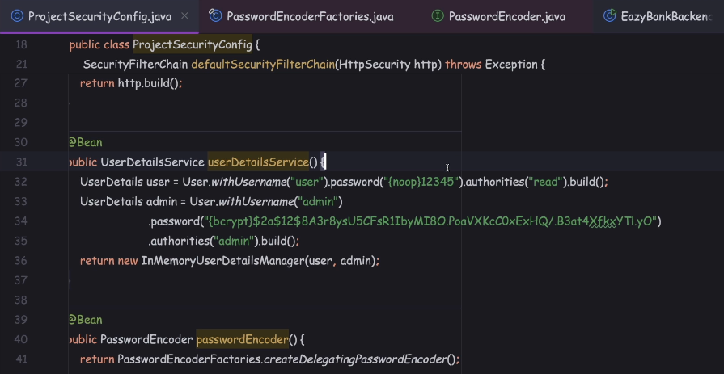

 Demo of CompromisedPasswordChecker

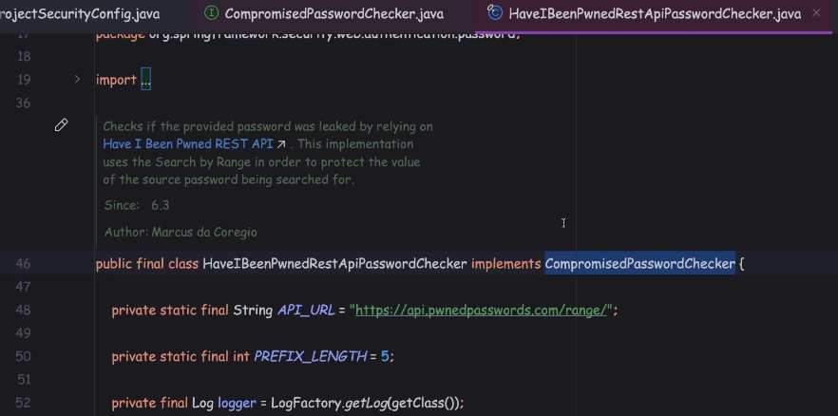

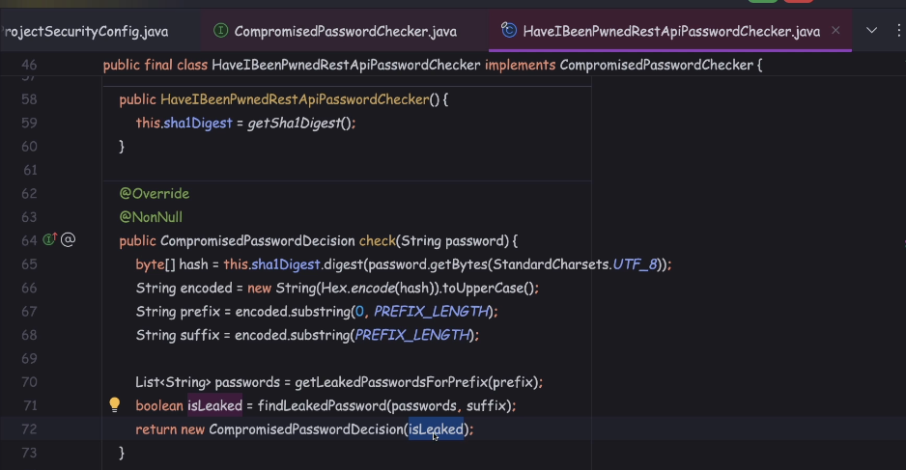

Using admin, 54321 getting below error even for bcrypt use case

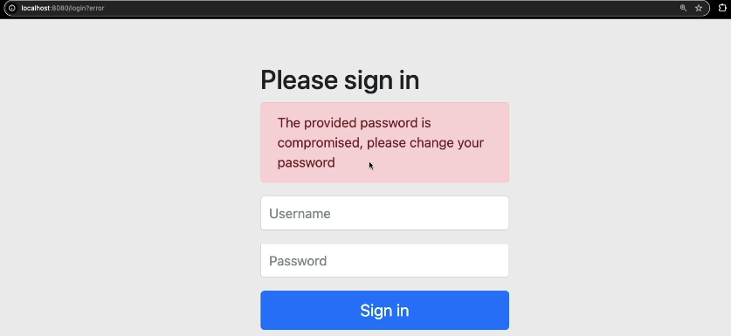

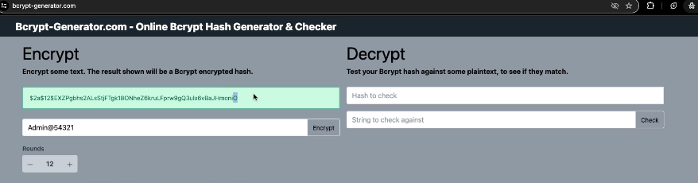

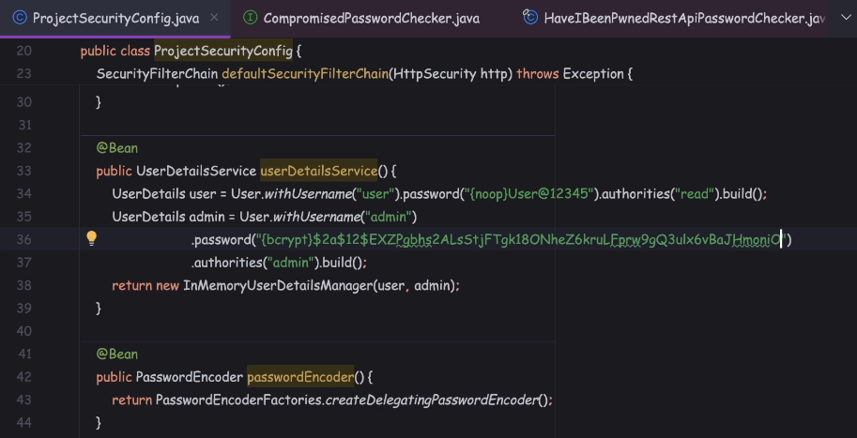

Deep Dive of UserDetailsService & UserDetailsManager Interfaces

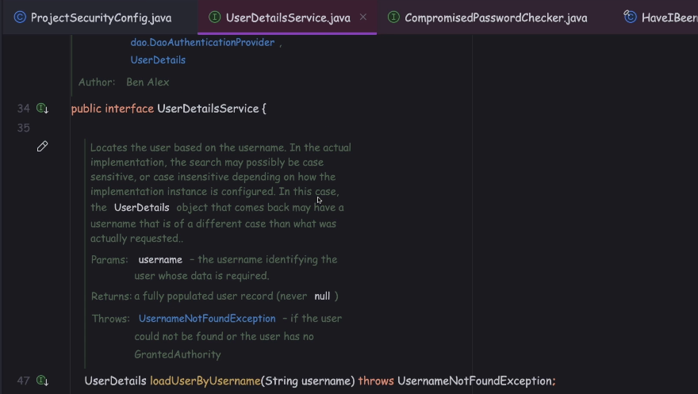

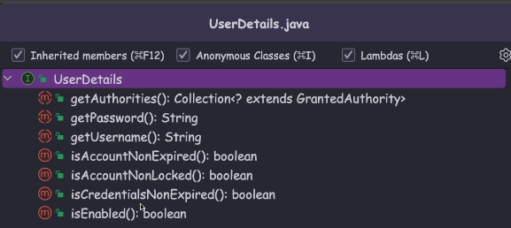

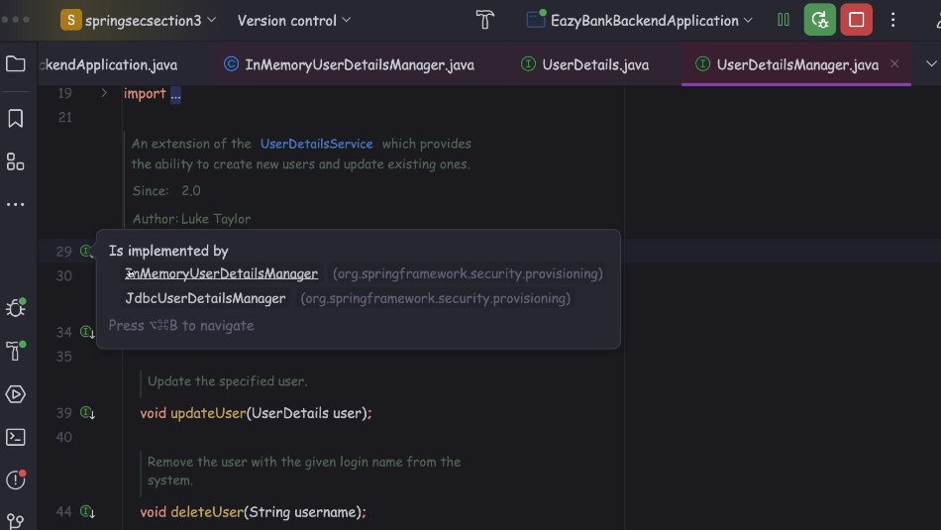

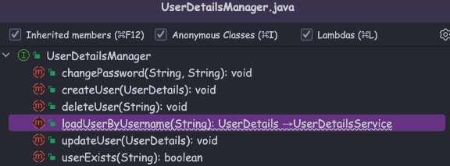

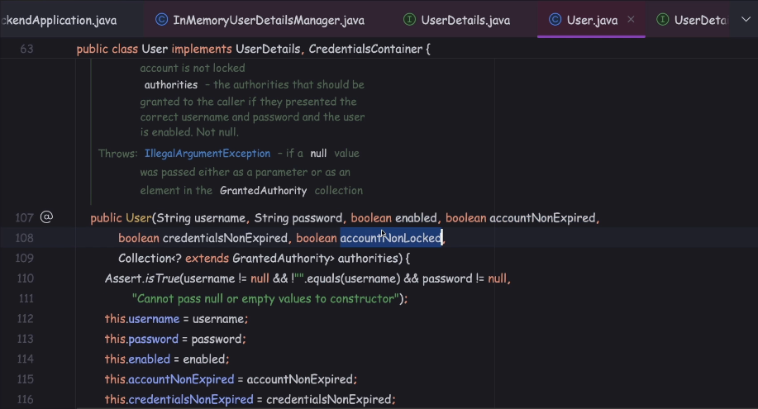

Deep Dive of UserDetails & Authentication interfaces

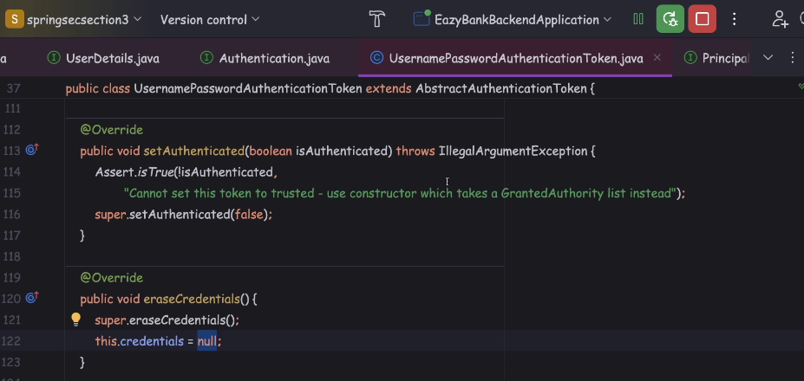

once the authentication is successful, framework is going to call this method

which is eraseCredentials().

So this method, it is simply setting the credentials value to null,

without the password details of the authenticated user, they're going to be erased.

